CST4530 Lab B. Windows Server Group Policy

Hendon Tutor: Dr Xiaochun Cheng

M00783479

AIM: Understanding Group policies using Windows server. A major part of designing

the security for an organization is the planning and configuration of Group Policies. This practical lab will give you a hands-on experience in Active Directory environment.

**Group Policy:**

Group policy are collections of user and computer configuration setting that specify how programs, network resources and the operating system work for users and computers, sites, domains and Organizational Unit (OU). For example, using group policies you can determine the programs that are available to users, the programs that appear on the user’s desktop, and start menu options. We might look at group policies as a grouping of policy settings that are linked to computers, sites, domains and OUs.

There are two types of Group Policies (GPOs).

• Local GPOs: One GPO is stored on each computer whether or not it’s part of a network environment. A local GPO affects only the computer on which it is stored. However, the local GPO settings could be overridden by non-local GPOs, the local GPO is the least influential if

the computer is part of a network. The local GPO is stored in %Systemroot%\System32\GroupPolicy.

• Non-local GPOs: They are created in Networks environment, and

must be linked to a site, OU and domain. To be applied to either

computer or user.

By default, when Active Directory service is set up, two non-local GPOs are created.

i. Default domain Policy: this GPO is linked to the domain, and it affects

all users and computers in that domain including the domain

controllers through Group Policy inheritance.

ii. Default domain controllers Policy: This GPO is linked to the Domain

controllers OU and it generally affects only the domain controllers.

Non-local group policies are stored on %Systemroot%\Sysvol\Domain Name\Policies\ GPO.

**Implementing a GPO:**

The tasks for implementing a GPO include the following:

A. Creating a GPO

B. Creating a MMC for the GPO

C. Delegating Administrative permission for the GPO

D. Configuring Group Policy settings for the GPO

E. Disabling unused Group Policy settings

F. Indicating any GPO processing exceptions

G. Linking the GPO to a site, domain or OU

H. Modifying a GPO

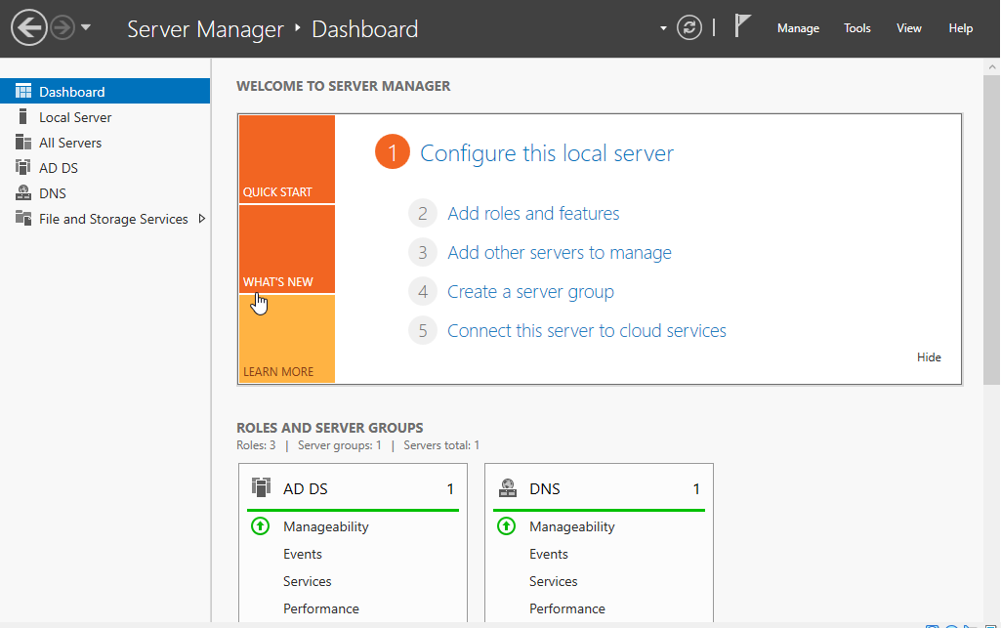

Creating a GPO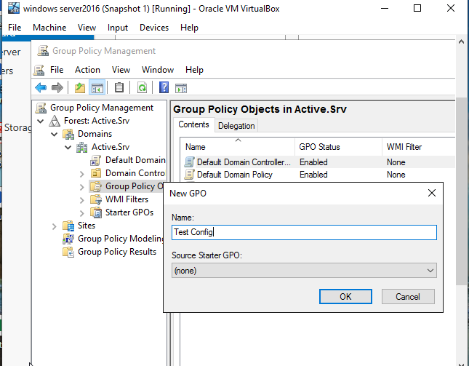

Creating An MMC for GPO

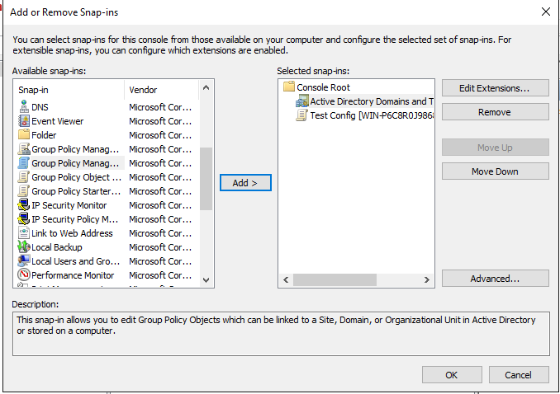

Delegating Administrative permissions for the GPO

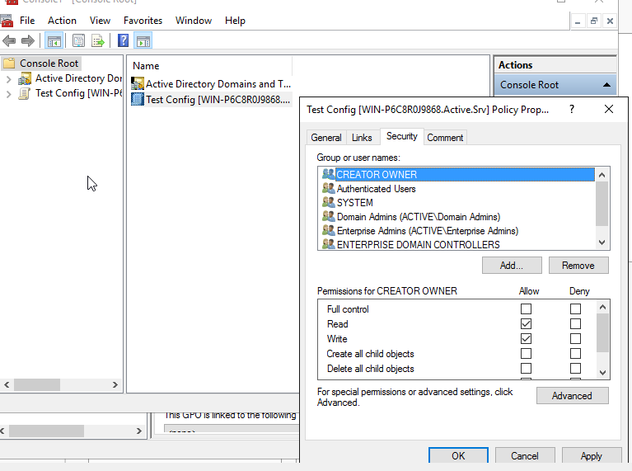

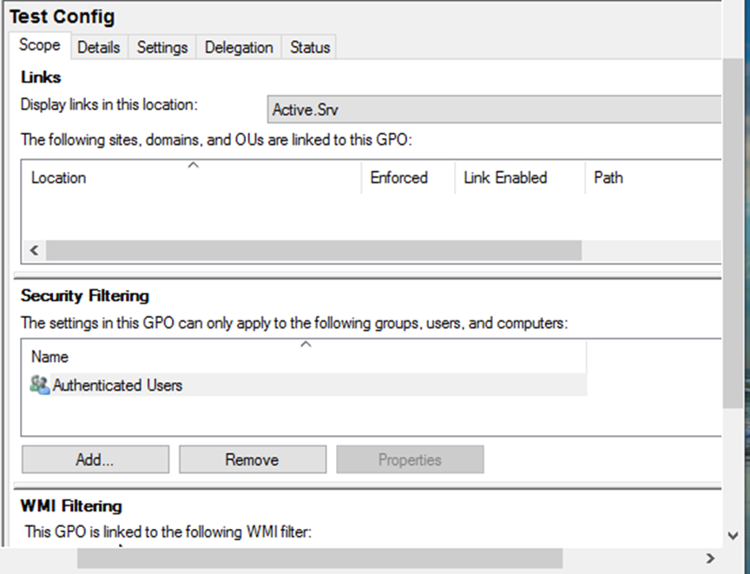

Delegating control for GPO object linking

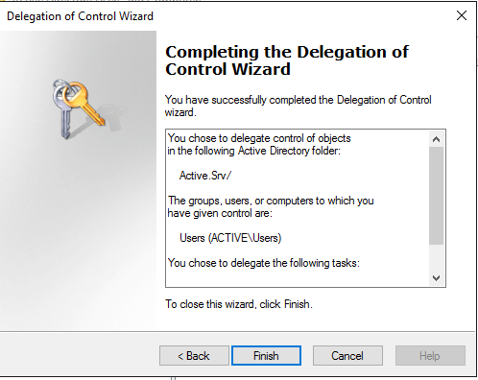

D. Configuring Group Policy settings for the GPO

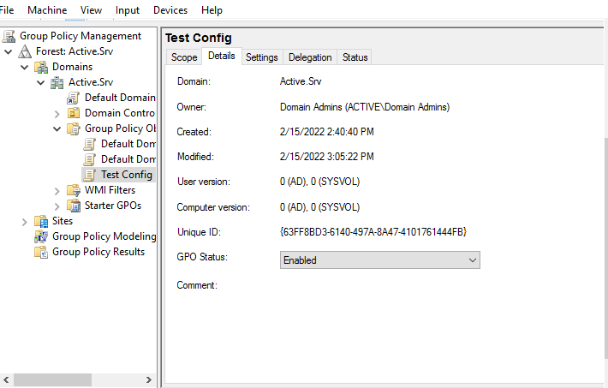

Indicating any GPO processing exceptions

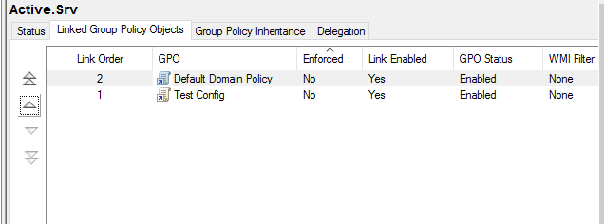

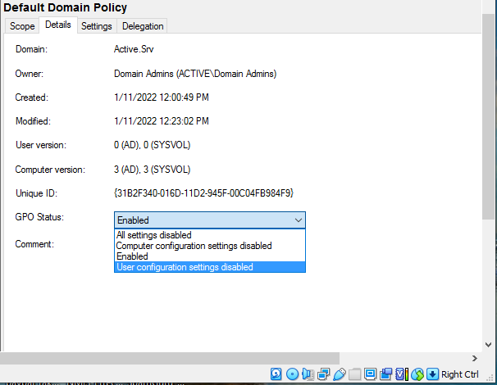

To specify the block policy Inheritance option.

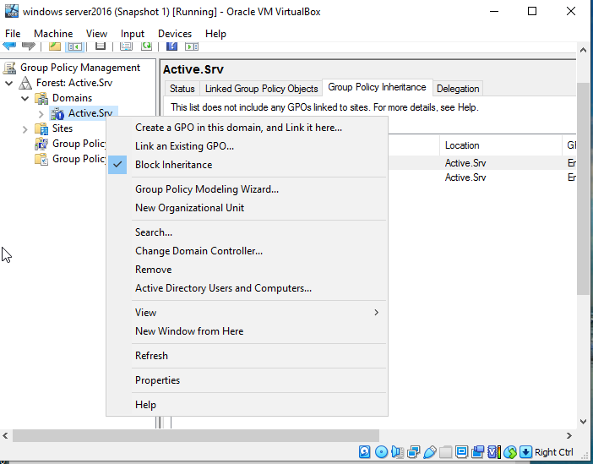

linking GPO

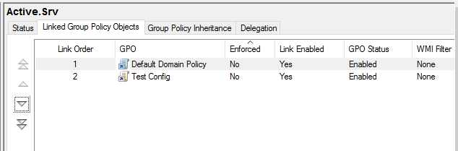

Removing GPO link:

